Ethics Council Meeting Minutes

August 13, 2026

Call to Order
Erica Fouss, Ethics Council member, called the meeting to order at 6:15 p.m. on Thursday, August 13, 2026.

Roll Call
Members Present: Howard Heffelfinger, Erica Fouss
Members Absent: Louis Borowicz
Others Present: Melinda Draper, Assistant Superintendent; Amy Funk, Senior Director of Operations and Finance; and Jennifer Bianchi, Executive Assistant

Public Comments
None

Approval of June 11, 2026 Minutes
Howard Heffelfinger moved to approve the minutes from the June 11, 2026 Ethics Council meeting. Erica Fouss seconded the motion. The motion carried.

Consent Agenda
The Ethics Council reviewed the following contract with no known conflict: Intellinetics, Inc.
Howard Heffelfinger moved to approve the consent agenda. Erica Fouss seconded the motion. The motion carried.

Adjournment
Erica Fouss moved to adjourn the meeting. Howard Heffelfinger seconded the motion. The meeting adjourned at 6:17 p.m.

Respectfully submitted,
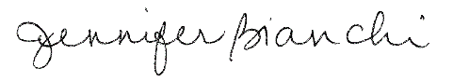
Jennifer Bianchi
Executive Assistant

