Ethics Council Meeting Minutes

June 11, 2026

Call to Order
Louis Borowicz, Ethics Council Chair, called the meeting to order at 6:16 p.m. on Thursday, June 11, 2026.

Roll Call
Members Present: Louis Borowicz, Howard Heffelfinger
Members Absent: Erica Fouss
Others Present: Kristine Hodge, Superintendent; Amy Funk, Senior Director of Operations and Finance; and Jennifer Bianchi, Executive Assistant

Public Comments
None

Approval of November 13, 2025 Minutes
Howard Heffelfinger moved to approve the minutes from the November 13, 2025 Ethics Council meeting. Louis Borowicz seconded the motion. The motion carried.

Consent Agenda
The Ethics Council reviewed the following contract with no known conflict: HelpLine of Delaware and Morrow County.
Howard Heffelfinger moved to approve the consent agenda. Louis Borowicz seconded the motion. The motion carried.

Adjournment
Howard Heffelfinger moved to adjourn the meeting. Louis Borowicz seconded the motion. The meeting adjourned at 6:18 p.m.

Respectfully submitted,
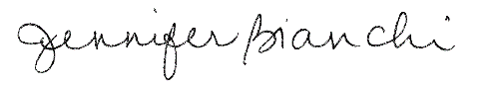
Jennifer Bianchi
Executive Assistant

