Finance Committee Meeting Minutes
Tuesday, March 11, 2025

Call to Order
Michael Fulton, Finance Committee Chairperson, called the meeting to order at 4:45 p.m. on Tuesday, March 11, 2025.

Roll Call
Members present: Michael Fulton, Ted Klecker and Erica Fouss
Others present: Kristine Hodge, Superintendent; Amy Funk, Senior Director of Operations and Finance; Melinda Draper, Senior Director of Compliance and Administrative Services; Allison Walters, Director of Human Resources; Chase Waits, Director of Communications and Community Engagement; Jennifer Bianchi, Executive Assistant; and Eric Penkal, Director of the Delaware County Guardianship Services Board

Public Comments
None

Approval of Minutes
Erica Fouss moved to approve the minutes from the October 1, 2024, Finance Committee meeting. Michael Fulton seconded the motion. The motion carried.

Discussion Items
- Agreement to Fund the Delaware County Guardianship Services Board
Ted Klecker moved to recommend that the Board approve the Agreement to Fund the Guardianship Services Board in the amount of $108,750. Erica Fouss seconded the motion. The motion carried.

- Levy Planning
Amy Funk and Kristine Hodge presented the committee with information for planning a levy and addressed their questions.

- Future Meeting
The Committee will meet on August 5, 2025, at 4:30 p.m. to continue the levy planning process.

Adjournment
Erica Fouss moved to adjourn the meeting. Ted Klecker seconded the motion. The motion carried. The meeting adjourned at 6:32 p.m.

Respectfully submitted,
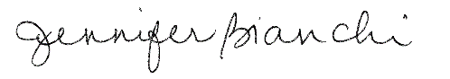
Executive Assistant

