Ethics Council Meeting Minutes
Thursday January 9, 2025

Call to Order
Louis Borowicz, Ethics Council Chair, called the meeting to order at 6:15 p.m. on Thursday, January 9, 2025.

Roll Call
Members Present: Louis Borowicz, Howard Heffelfinger, and Erica Fouss
Others Present: Kristine Hodge, Superintendent; Amy Funk, Senior Director of Operations and Finance and Jennifer Bianchi, Executive Assistant

Public Comments
None

Approval of December 12, 2024 Minutes
Howard Heffelfinger moved to approve the minutes from the December 12, 2024 Ethics Council meeting. Erica Fouss seconded the motion. The motion carried.

Consent Agenda
The Ethics Council reviewed the following contracts with no known conflict: Reliable, Independent, Efficient, LLC (RIDE) and Three C Care Healthcare, LLC.
Erica Fouss moved to approve the consent agenda. Howard Heffelfinger seconded the motion. The motion carried.

Adjournment
Howard Heffelfinger moved to adjourn the meeting. Erica Fouss seconded the motion. The meeting adjourned at 6:18 p.m.

Respectfully submitted,
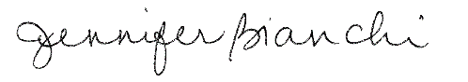
Jennifer Bianchi
Executive Assistant

