Ethics Council Meeting Minutes
Thursday, February 8, 2024

Call to Order
Louis Borowicz, Ethics Council Chair, called the meeting to order at 6:18 p.m. on Thursday, February 8, 2024

Roll Call
Members Present: Louis Borowicz and David Moser
Members Absent: Howard Heffelfinger
Others Present: Kristine Hodge, Superintendent; Amy Funk, Senior Director of Operations and Finance; Chase Waits, Senior Director of Communications and Community Engagement; and Jennifer Bianchi, Executive Assistant

Public Comments
None

Approval of January 11, 2024 Minutes
David Moser moved to approve the minutes from the January 11, 2024 Ethics Council meeting. Louis Borowicz seconded the motion. The motion carried.

Staff Requests
David Moser moved to approve Deb Faulkner’s request for secondary employment based on the knowledge that no known conflicts exist. Louis Borowicz seconded the motion. The motion carried.

David Moser moved to approve Jamie Fox’s request for secondary employment based on the knowledge that no known conflicts exist. Louis Borowicz seconded the motion. The motion carried.

Consent Agenda
The Ethics Council reviewed the following direct service contracts with no known conflicts: Cornerstone Supported Living, LLC and Sierra Absolute Care, LLC.
David Moser moved to approve the consent agenda. Louis Borowicz seconded the motion. The motion carried.
Adjournment
David Moser moved to adjourn the meeting. Louis Borowicz seconded the motion. The meeting adjourned at 6:20 p.m.

Respectfully submitted,
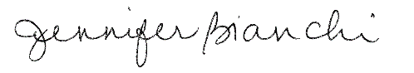
Jennifer Bianchi
Executive Assistant

