Incident Reporting Form
MUI Hotline during business hours: 740-201-3608 ~ After Hours: 740-369-3316 (HelpLine)
Email report to MUI@dcbdd.org or fax to 740-201-3608 by 3 pm the following business day.
Provider Name & Address:
Individual’s Name: |  | DOB:
Address: |  | City/County:
Date of Incident: Time of Incident: AM/PM
Location of Incident (home in bathroom, at the mall, lunchroom at work):

Description of Incident (Who, What, Where, When):
Injury – Describe Type & Location:
Immediate Action to Ensure Health & Welfare of Individuals:
Name of Primary Person Involved: | Relationship to Individual:
Witnesses to Incident: | Others Involved (attach statements of witnesses):
Type of Notification | Name/Title |  | Date/Time
Guardian / Advocate
Service and Support Administrator
Service and Support Administration Supervisor

Licensed or Certified Provider

Staff or Family living at the Individual’s home & responsible for the individual’s care.
Law Enforcement (Name, Badge Number, Jurisdiction, and contact information required)
Children Services (if under 21 years old and abuse or neglect is suspected) 740-833-2340

Support Broker (If applicable)
A. Further Medical Follow-up:

B. Administrative Action:

Body Part Injured:
0 Head or Face 0 Neck or Chest
0 Mouth / Teeth 0 Abdomen
0 Hands / Arms 0 Back / Buttocks
0 Feet / Legs 0 Genitals
0 Other

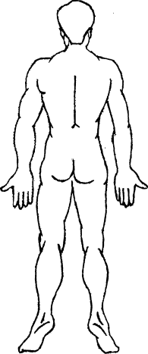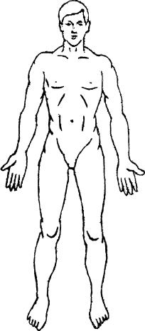

Signature of person completing form Title Date

Complete for UI Investigations:
Causes and Contributing Factors:

Preventive measures:

